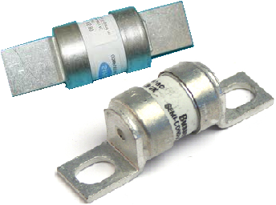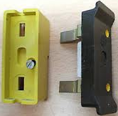

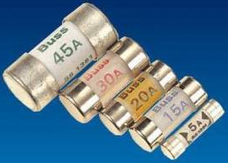 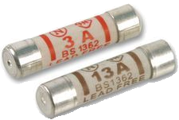

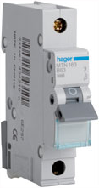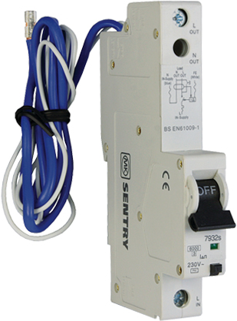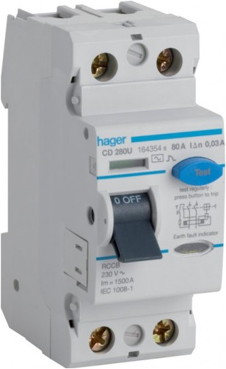

Advantage: Simple to check if blown

Disadvantage: Danger of being replaced with wrong size fuse wire

Advantage: it can break a large current safely

Disadvantage: Expensive to replace

Advantage: Accurate current rating

Disadvantage: Cannot break large fault currents

Advantage: Inexpensive a simple to replace

Disadvantage: Can easily install wrong size

Advantage: Power can be quickly restored without any repair

Disadvantage: Contain mechanical moving parts

_________________________________________________________________________________

OVERLOAD EARTH LEAKAGE